Question 7)
Testing provided code and editing
For all test cases: What is the order of accuracy in space and in time? Show that you have reached convergence in space and time by showing results for at least two spatial and two temporal resolutions. Try various CFL-numbers including one. Interpret your results. Do not only use a time counter but use the actual time in your time-loop.
Test-Case-0: Impose h = H₀ for constant w₀ = W₀ (such that A = W₀H₀) also at the inflow boundary and as initial condition; check that nothing happens. Take L_{e} = 5000m,W₀ = 100m,−∂_{s}b =0.001,g = 9.81m/s²,C_{m} = 0.1 (C_{m} ∈ [0.05,0.15]). Plot A(s,t), water depth h(s,t) and discharge Q(s,t) = A(s,t)u(s,t) = F(A,s) for some times. Discharge should be constant Q = Q₀. Why is the discharge not constant after the pulse has passed?

Code: test0b
The scheme is first order. Checked parameters were set to: Lx=5000, w0=100, slope =-0.001, grav =9.81, cm=0.1. Plotting functions within code edited. A constant h has been imposed in the initial conditions shown below, showing h,w,Q and A at t=0.
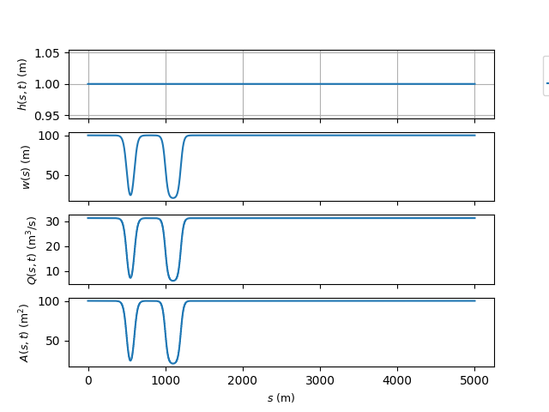
Run 1: Running the code at nx=5000, CFL=0.5, T_end= 5 hours (3600*5) yields the following results:
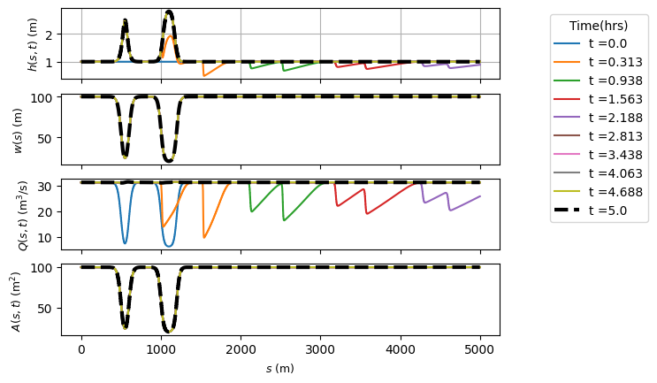
The final solution (t=5hrs) is shown by a black dashed line. The height changes from its initial condition to increase when the width decreases. The discharge settles to a constant value, after fluctuating at earlier timesteps.
Run 2/3/4: The code was run at a coarser spatial resolution, with Nx=500 ,1000 and 2500.
Results for nx=500:
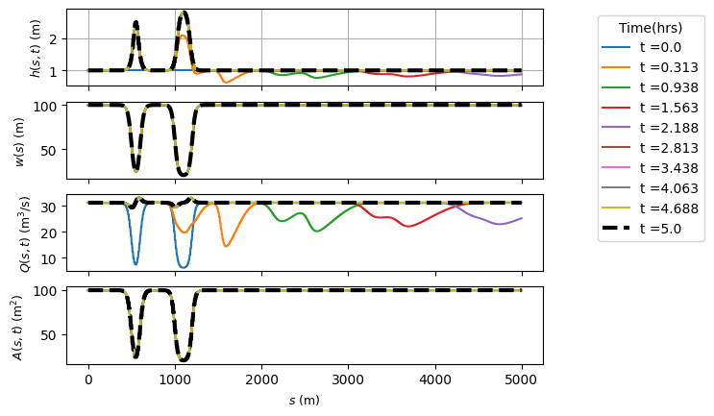
Results for nx=1000:
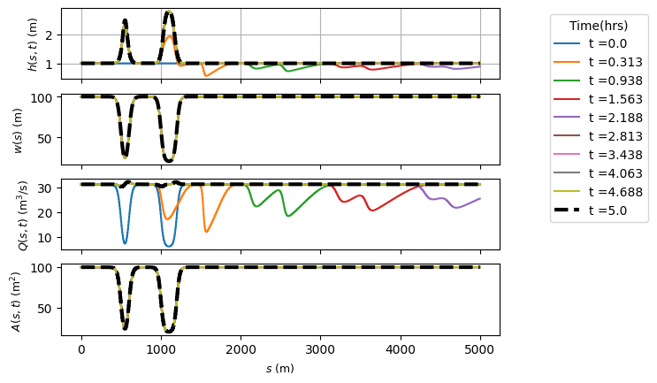
Nx=2500
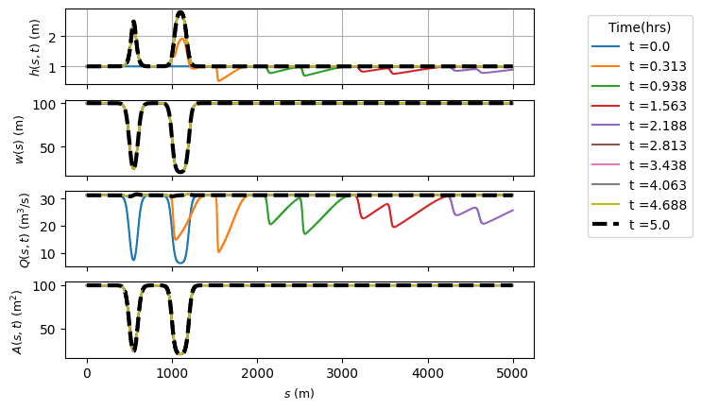
Results are similar, although bigger fluctuations in the final value of Q for coarser resolutions.

Editing the CFL number for Nx=5000
CFL=1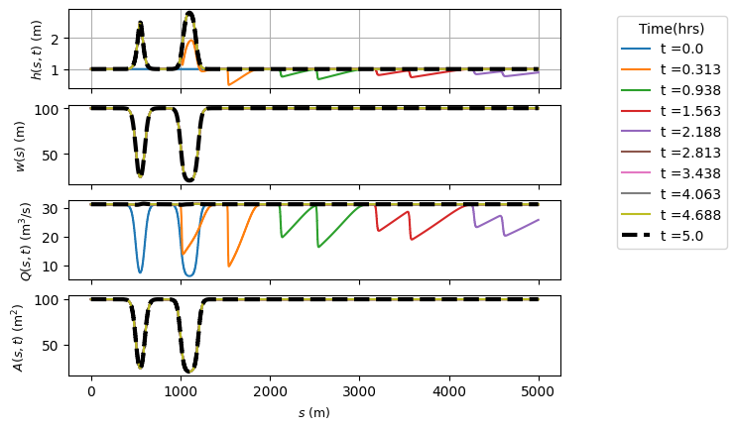
CFL=0.2
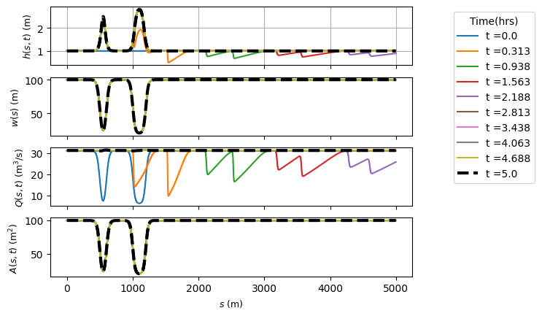
Plotting the three CFL numbers for nx=5000 on one graph shows the results are identical

